Shortcut for Users Accessing Earnings Statement with Mobile Devices
New functionality is available in the My UI Info Earnings Statement application that allows mobile device users logging into Earnings Statement to create a shortcut on the home screen of their device. Clicking on the shortcut will then take the user directly to the Earnings Statement login screen.
This new feature uses native mobile technology, so it doesn’t matter what device you are using. It works with iPhones, iPads, Androids and other mobile devices. The following are instructions for adding the shortcut for both Apple and Android devices.
Adding an Earning Statement shortcut to the home screen of a smart device
Step 1. Access the earning statement on the System HR Services website at www.hr.uillinois.edu – Use the Quick Link for Earnings Statement or use the My UI Info section (go.uillinois.edu/myinfo).
Step 2. Click the Access Earning Statement button in the “Take Action” field
Step 3. Log in using your NetId and Password
Note: Users accessing their Earnings Statement off campus may need to authenticate with 2FA before going to step 4.
Step 4. On the screen that asks for your 4-digit pin,
For Apple Device - Phone, Tablet, I-Pad, etc | For Android
tap the icon located at the bottom of the screen  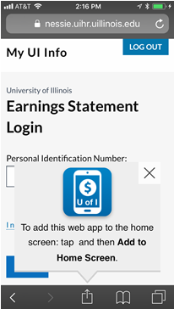 | tap the icon at the top of the screen  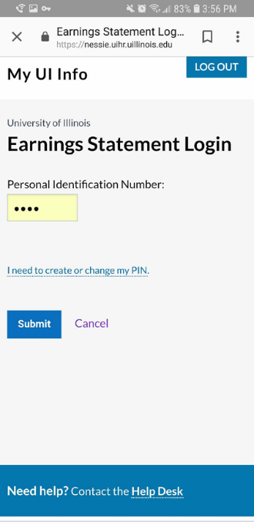

Step 5. Tap “Add to Home Screen”.
For Apple Device - Phone, Tablet, I-Pad, etc | For Android
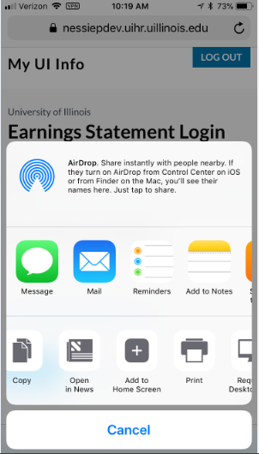 | 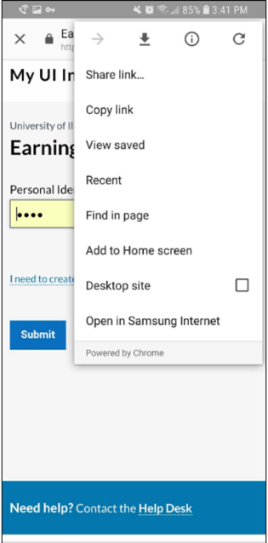

Step 6. Tap “Add”
For Apple Device - Phone, Tablet, I-Pad, etc | For Android
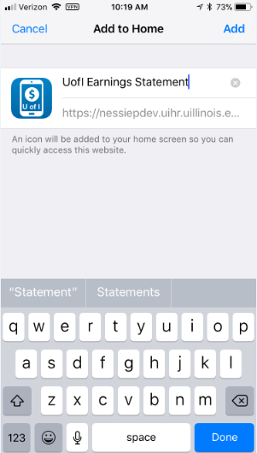 | 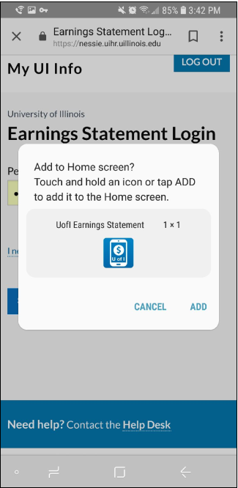
The Icon should now be added to the Home Screen

